Data cleaning and Transformation:  
Data cleaning is the process that removes data that does not belong in your dataset. Data transformation is the process of converting data from one format or structure into another.

**Step-1:**

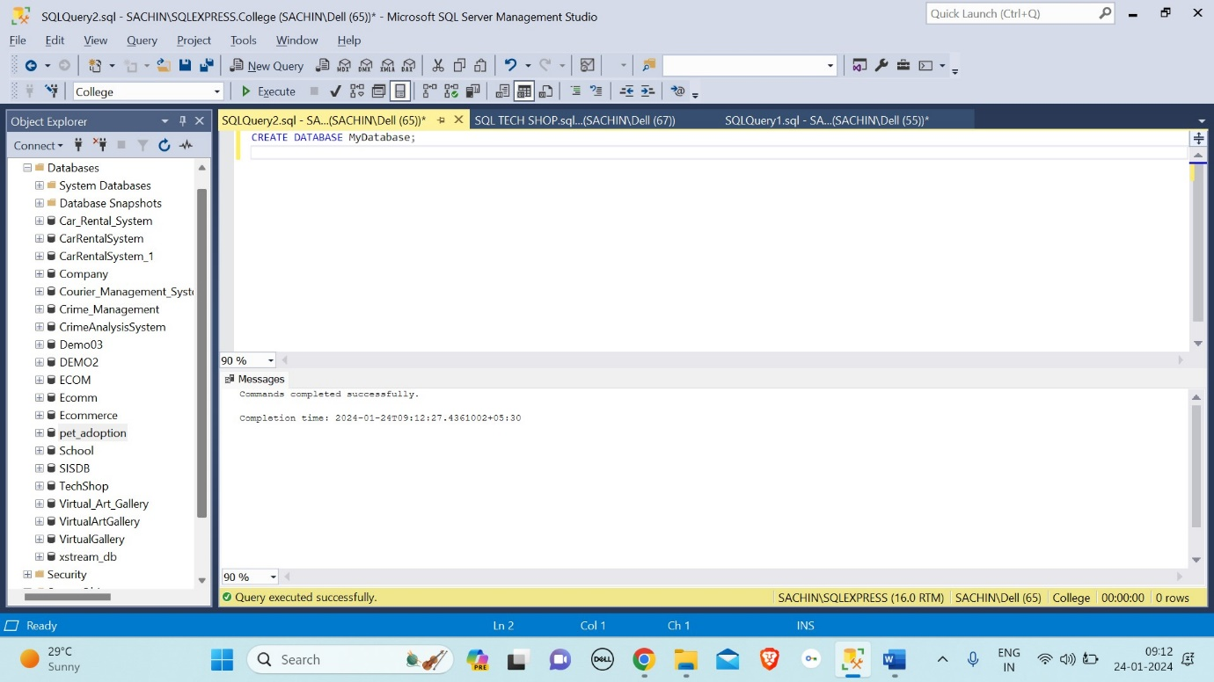

**Step-2:**

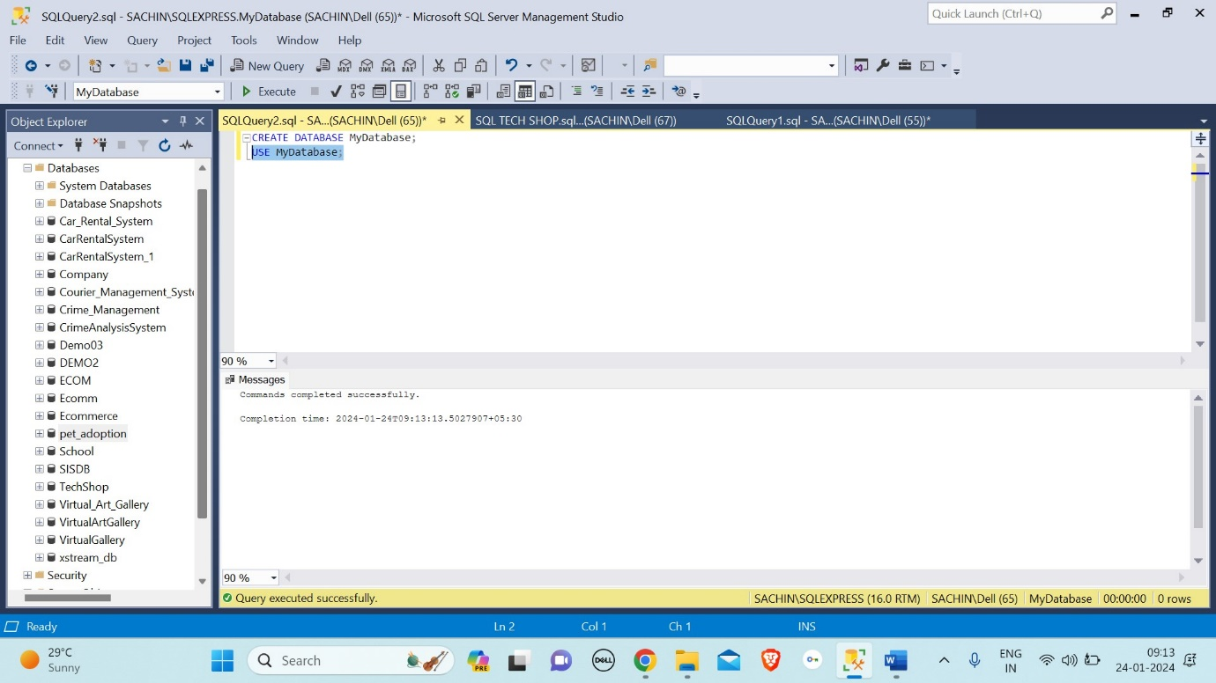

**Step-3:**

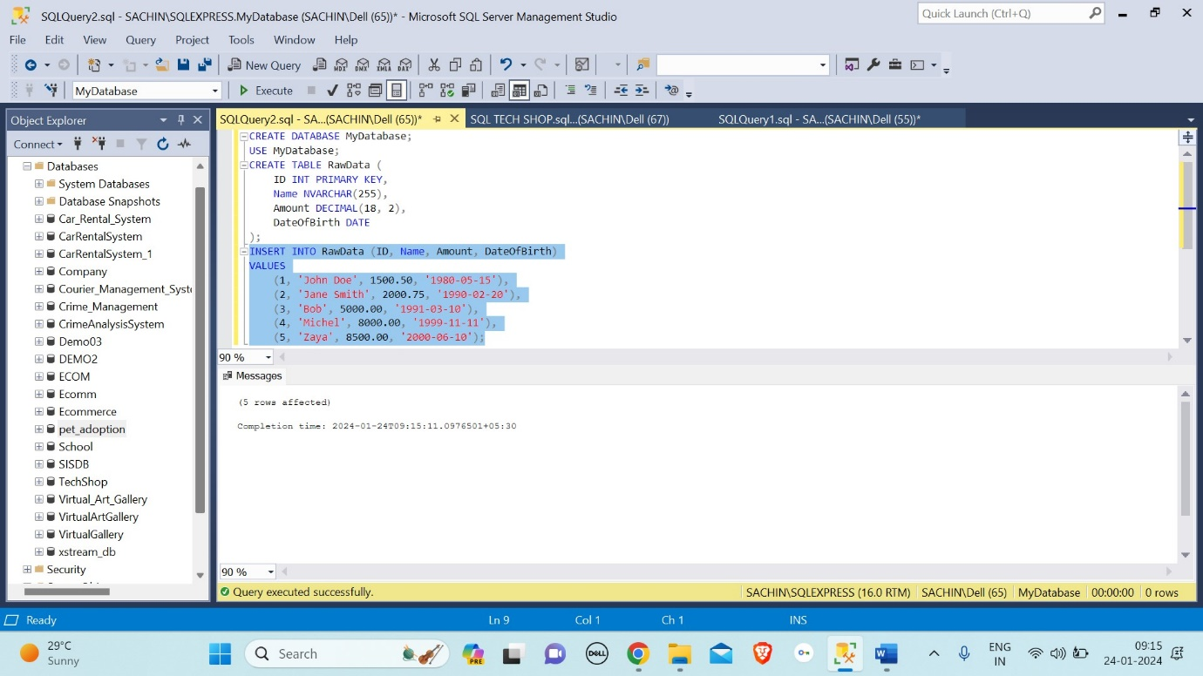

**Step-4:**

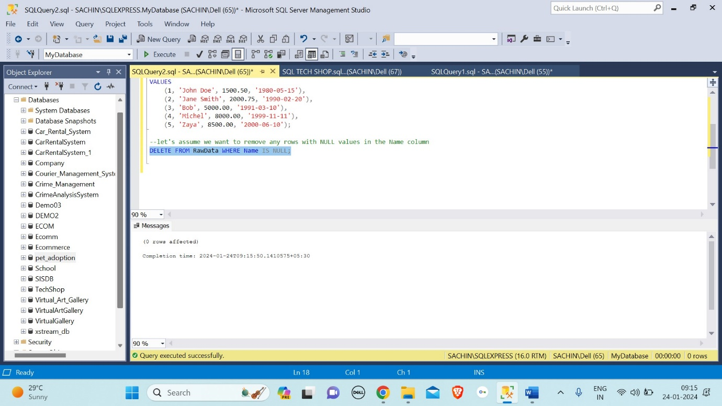

**Step-5:**

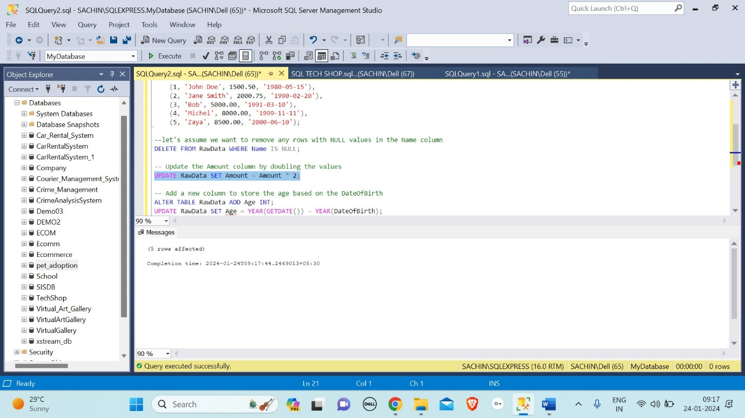

**Step-6:**

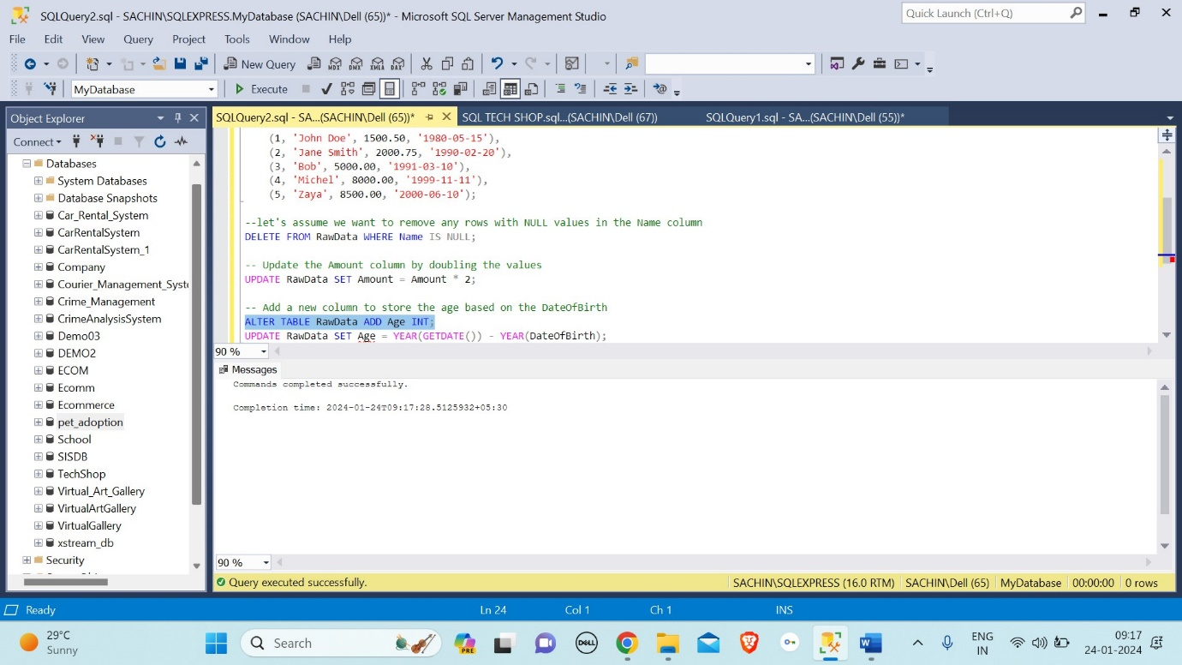

**Step-7:**

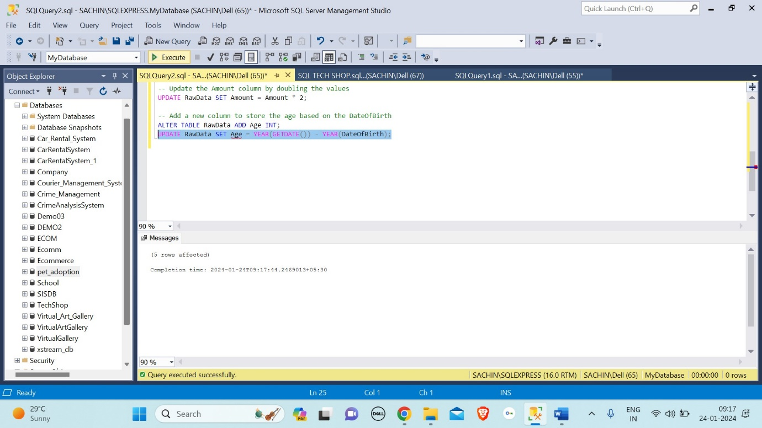

**Step-8:**



**Step-10:**

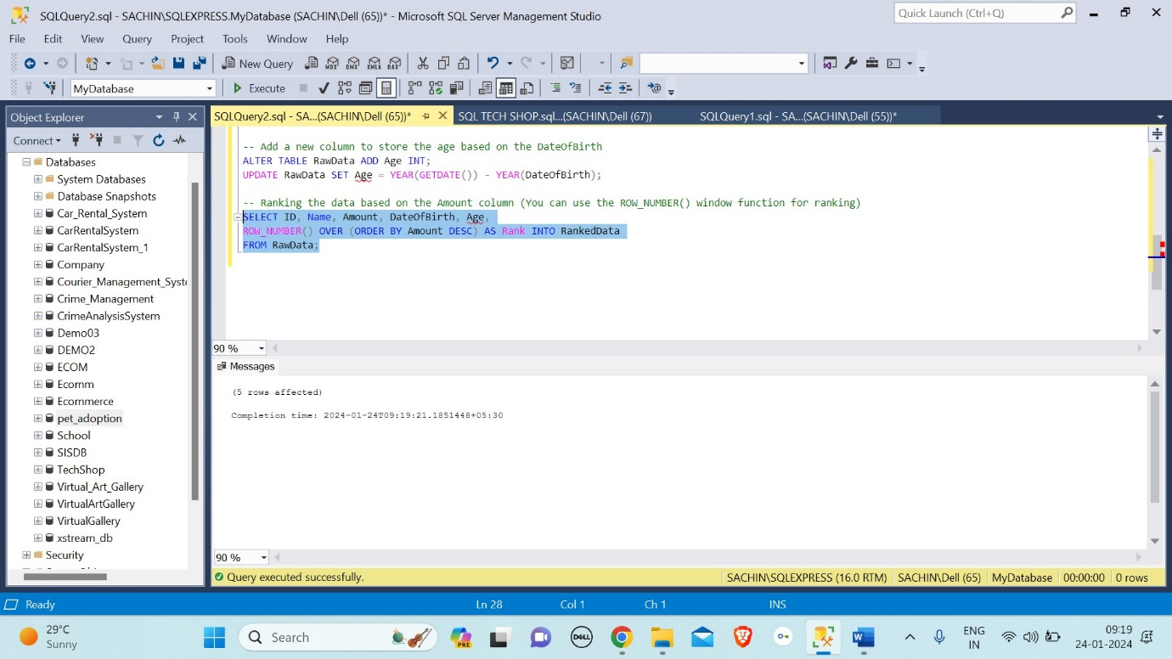

**Step-11:**

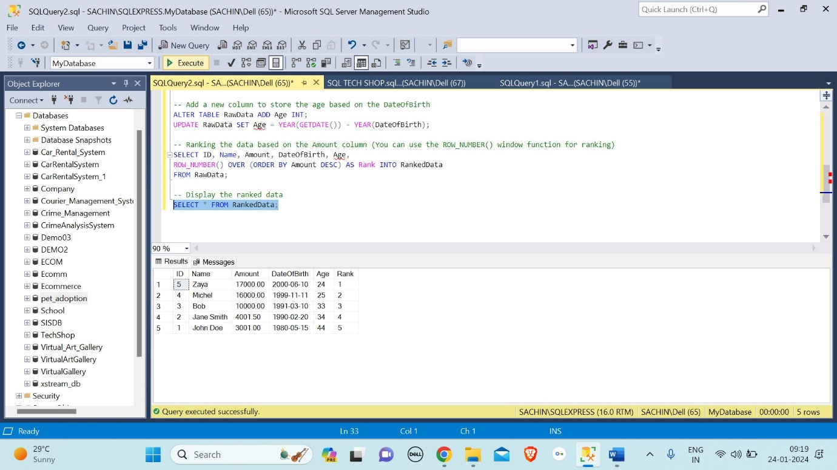

ss

Stored Procedure:

A stored procedure is a prepared SQL code that you can save, so the code can be reused over and over again. So if you have an SQL query that you write over and over again, save it as a stored procedure, and then just call it to execute it.

**Step-1:**

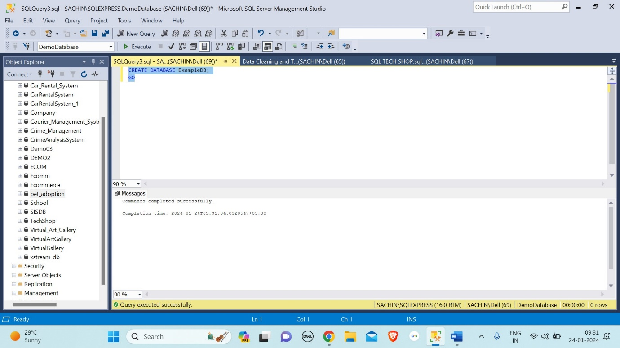

**Step-2:**

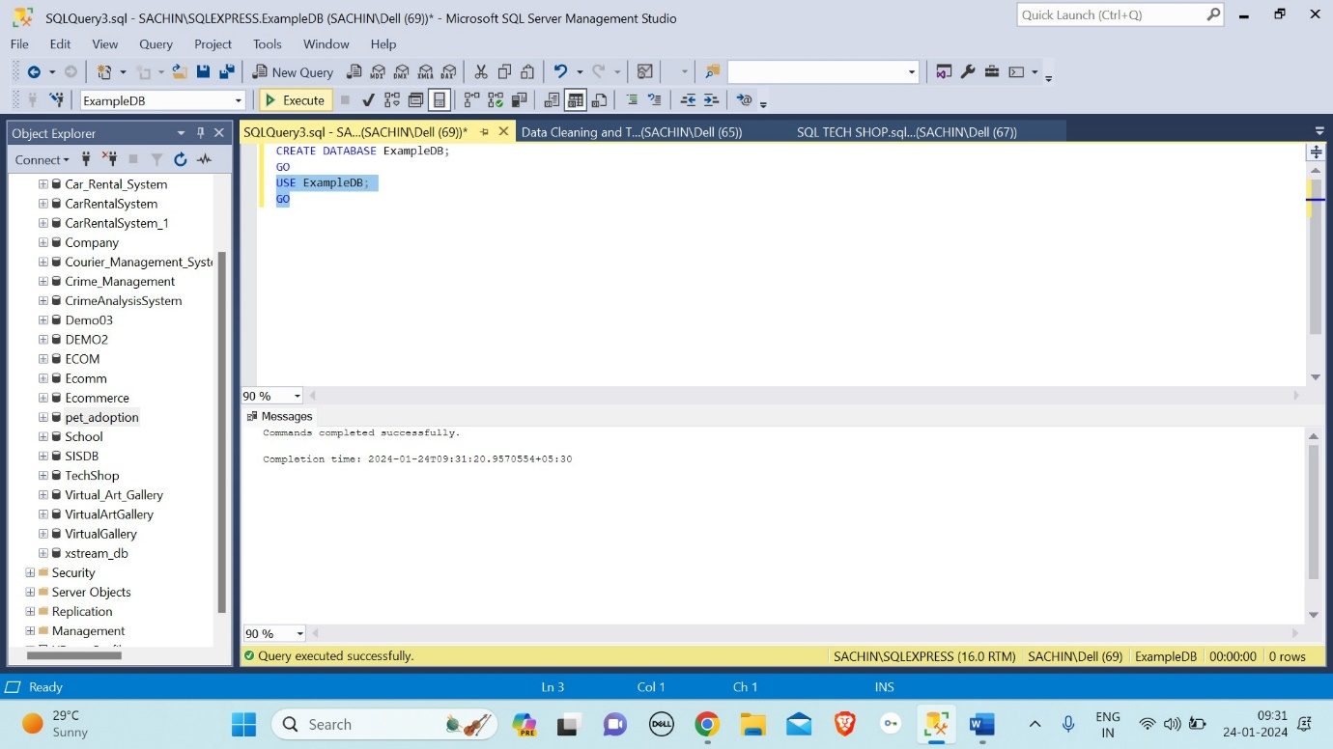

**Step-3:**

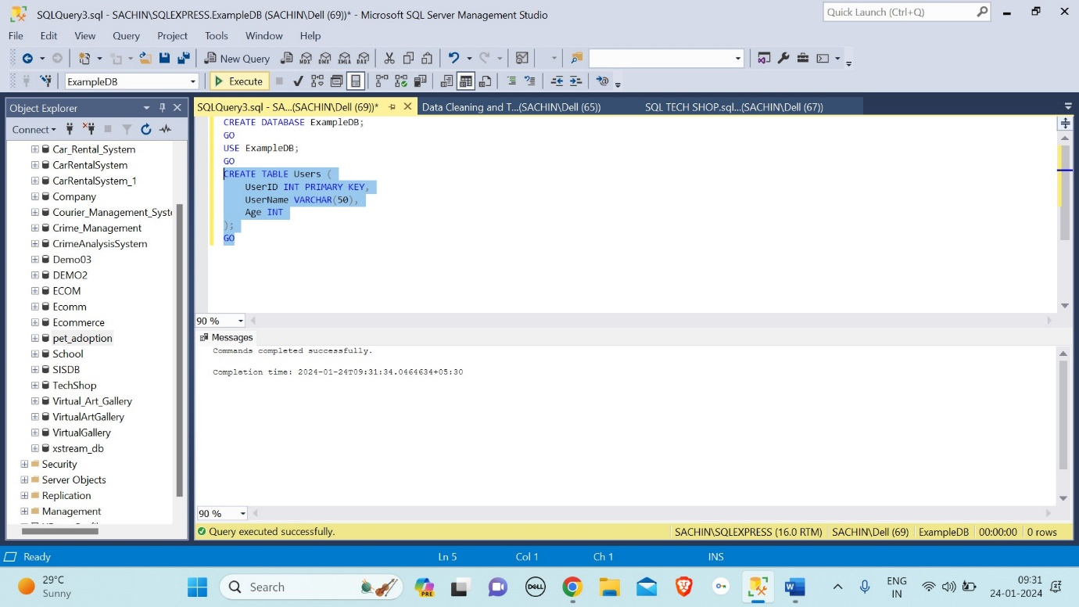

**Step-4:**

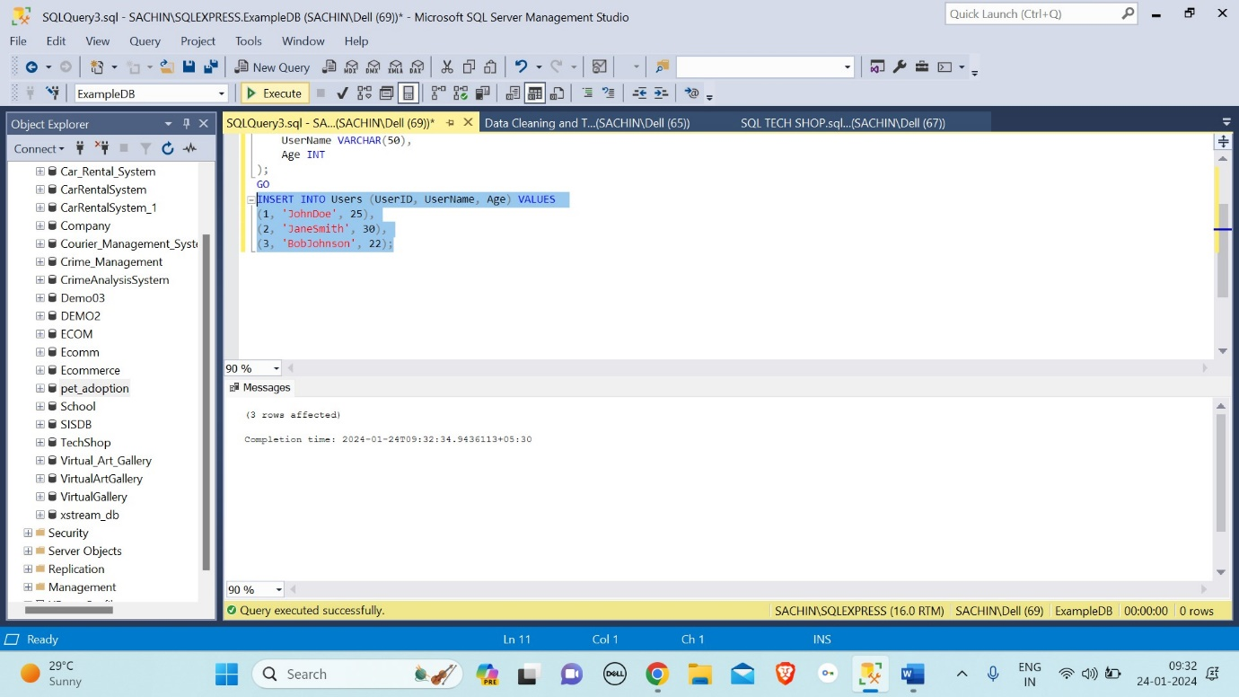

**Step-5:**

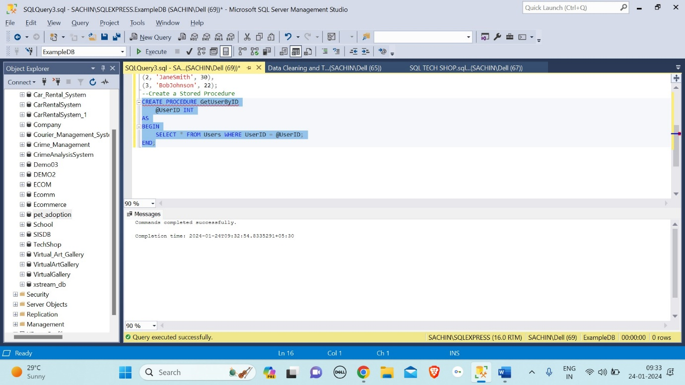

**Step-6:**

